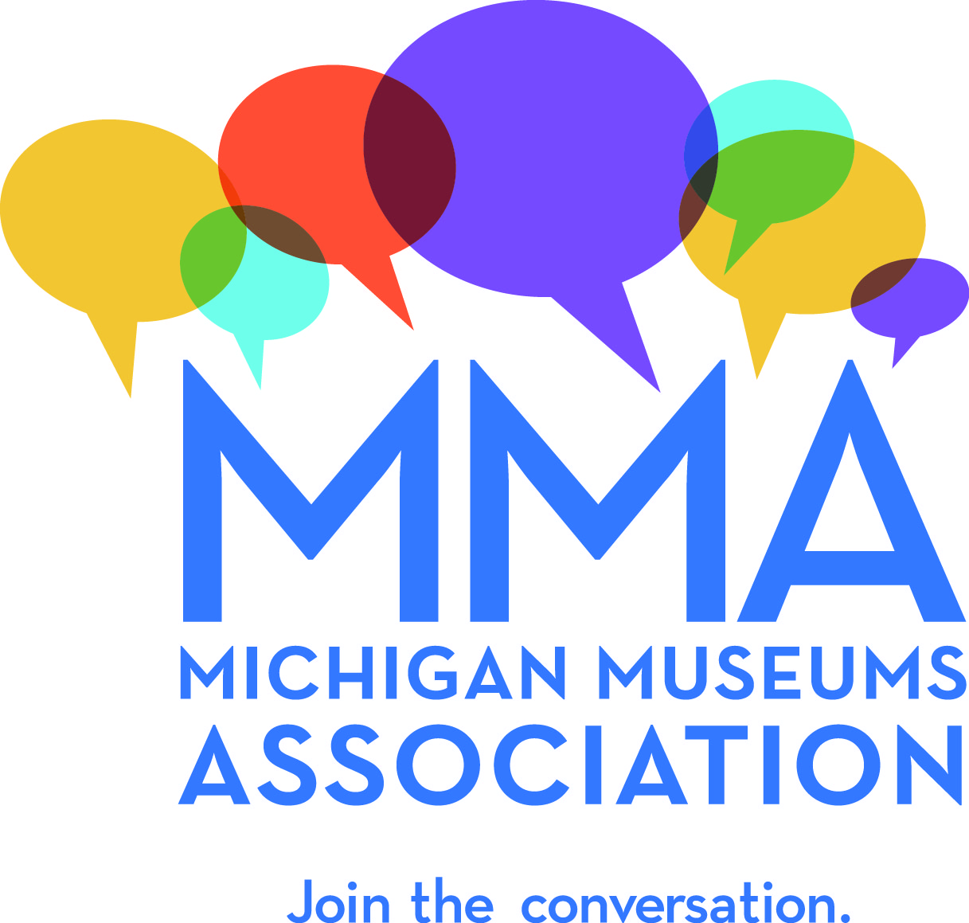
Contact: Lisa Craig Brisson
Michigan Museums Association
michiganmuseums.org
lcbrisson@michiganmuseums.org
Phone 313 334-7643
Fax 313 908-5408
PO Box 5246
Cheboygan, MI 49721
Press Release

Michigan Museums Association Awards Museum Workers from across the state at the 2014 MMA Quest for Excellence Awards
October 16, 2014, Cheboygan, MI: Museum professionals, volunteers, and supporters recently gathered on Mackinac Island, Michigan for the 2014 Annual Michigan Museums Association Conference, as well as the Quest for Excellence Awards. These awards are given annually by the association to acknowledge excellence in several areas and were presented this year on September 29. Four awards were given to museum docents, directors and historical societies. The recipients of this year’s awards are:

- Fannie Hoeksema, Holland Museum – Unsung Hero Award
- The Birmingham Historical Museum and Park – Best New Experience “An Afternoon Backstage with Chad Smith”
- Graham Beal, Director, The Detroit Institute of Arts – Peninsula’s Prize
- Gene Jenneman, Executive Director, Dennos Museum – President’s Award

It is such an honor to be able to recognized some of the good work and dedicated service in Michigan’s museums. Michigan’s museums provide jobs and support communities. They educate children and engage families and groups. They preserve and share priceless works of art and historic artifacts, and promote scientific exploration and a better understanding of our shared Michigan culture. The individuals honored by us this year represent the thousands of people in our state who are passionate about their work in museums, and are well deserved. – Lisa Craig Brisson, Executive Director, MMA

Decades of Service

There is one thing in common with the recipients of this year’s Quest for Excellence awards – dedication. Fannie Hoeksema, 83, was nominated by Holland Museum’s Museum and General Manager, Taylor Wise-Harthorn for the Unsung Hero Award. Ms. Wise-Harthorn writes, “Fannie has been an education docent with the Holland Museum since 1996. She gives tours on Native Americans and Local history fir 2nd-4th graders. She also greets visitors to the galleries and shares her love of history and the community with Museum guests….Fannie has had many surgeries over the past few years, that has earned her the nickname “bionic woman”…Neither snow nor rain nor replaced knee nor wrist surgery can keep Fannie away from delivering her love of history, which is very fitting since the Holland Museum is located in the former Post Office! Fannie is truly a remarkable volunteer. The Holland Museum is truly lucky to have such a talented and amazing woman in our corner. We can never thank her enough for all that she has done and continues to do.”

Fannie was born in Freemont, Michigan and moved to Holland in the mid-90s and began volunteering at the Holland Museum. She has an MA in education and studied at both Calvin College and Central Michigan University. In her spare time, she loves to travel.

Recipient of this year’s Best New Experience Award, Director, Leslie Pielack of the Birmingham Historical Museum and Park, wrote to MMA about their recent event “An Afternoon Backstage with Chad Smith” - “The Birmingham Historical Museum and Park is working to re-invent itself and demonstrate its relevance to the community, to overcome the perception of being an old-fashioned museum with ‘dusty old stuff in display cases.’ We believe the best museum experience helps the visitor develop a deeper understanding of him/herself in a cultural context and we want to help people see our museum as contributing actively to their lives in meaningful ways.”

Through this approach, they have developed a new exhibition “The Sounds of Birmingham: A Community of Music” that explores the heritage of music in their community dating from the 19th century to present. A local celebrity, Chad Smith, drummer for the band, The Red Hot Chili Peppers, was able to contribute by displaying personal artifacts, memorabilia and stories of growing up in Birmingham. On June 16, 2014, the museum hosted a special event with Mr. Smith for a meet and greet, tour of the exhibition and a silent auction. During the event, Mayor Scott Moore also presented Mr. Smith with a key to the City of Birmingham. The event exceeded all expectations and in turn was able to raise much-needed funds for the museum.

MMA has awarded the Peninsula’s Prize this year to Graham W.J. Beal, Director, President and CEO of the Detroit Institute of Arts since 1999. This prize honors long and distinguished service by an individual to a single institution. While Beal has been at the DIA, he has overseen two major capital campaigns and oversaw the museum’s renovation and expansion, all while continuing to build a world-renowned collection. In addition, he has presided over some of the most tumultuous years in the history of the Detroit Institute of Arts. His dedication to ensuring the long-term survival of the institution included leading the drive to have taxpayers support the institution in three countries and stands, with dignity and professional ethics, against those who would use the artistic and cultural treasures of the museum to offset Detroit’s deficit.

Co-nominated by Nancy Bryk, Associate Professor of Historic Preservation at Eastern Michigan University and Bradley Taylor, Associate Director, Museum Studies at the University of Michigan, they wrote “Graham Beal must be commended for standing up to daunting challenges that would be bested other directors. We are pleased and proud that he works on behalf of Michigan’s fine Detroit Institute of Arts.

Eugene Jenneman, recipient of this year’s President’s Award was chosen by MMA President, Ron Bloomfield. Jenneman, has provided over 25 years of leadership to one of Michigan’s premier museums and cultural centers, the Dennos Museum Center at Northwestern Michigan University in Traverse City. Gene joined the NMC 1988 and has worked to establish relationships with artists in Asia, specifically China and South Korea and to develop a presence in the lives of people in Traverse City and surrounding areas.

Comments from Susie Janis, a Dennos volunteer who was there at the beginning: “Few people know that at the time the Dennos Museum was in its final building stages, the NMC Board of Trustees made a truly brilliant decision ...they hired the Museum's first director, Gene Jenneman, a year before it was completed. They realized they knew nothing about how a museum would operate from the inside out. By doing this, Gene was then able to "re-design" the inside, specifically the "behind the scenes" areas to accommodate not just the art to be stored but also to ensure that the art it would be receiving would be handled, stored and preserved in the best manner possible. This also included the service kitchen which would then efficiently serve the public both general and private. Thanks to years of collecting Inuit Art by Bernie Rink and his friend, Wilbur Munnecke, the Dennos had a sizable collection and enough to handle its own gallery within the museum. This collection grew in size thanks to the dedication and foresight of Gene Jenneman. The late Eugene Powers had a massive, very valuable, collection of Inuit Art. After his death his family had to decide "who" would receive this collection. They went on a search throughout the United States including major cities such as New York, Boston and Chicago to name a few. In the end, the Dennos Museum was chosen to be the recipient. The reasoning behind the Power family's decision was because of what Gene Jenneman had already put in place. Not just because the Dennos had an existing Inuit Art Gallery but also a program that third graders at our local Eastern elementary school had established for local children to connect with the Inuit children by communicating with them regarding their art, it's history, design and artists. Another factor was Gene had a "travelling program of Inuit Art" and at that particular time it was appearing in Muskegon, Michigan. The Powers felt because of these three factors their father's collection would never be shoved somewhere in a back museum room but would continually be showcased at the Dennos Museum which it so rightfully deserved.”

With an emphasis on face-to-face collaboration, the Michigan Museums Association shares expertise and resources to promote standards and practices that make the Michigan museum community thrive. MMA has been supporting the work of Michigan museums for nearly 60 years. Our members include the institutions, professionals and volunteers of the Michigan museum community who believe that strong museums help us better understand ourselves and our world. Every type of museum is represented and welcomed, including art, history, science, military and maritime, and youth museums, as well as aquariums, zoos, botanical gardens, arboretums, historic sites, and science and technology centers.

The 2015 Michigan Museums Association Conference will be in Ann Arbor, Michigan.

